CURRICULUM ON MILITARY KNOWLEDGE
  - Strand M1: Cadet Regulations
  - Level 11
This Strand is composed of the following components:
- Core Cadet Regulations
- Cadet Staff Regulations
- Regulations that Guide Us

“Earn it. Achieve it. Wear it.”

Table of Contents
B. Cadet Staff Regulations 3
Objectives 3
B1. Personnel (S-1) Regulations 4
a. CR 1, General Administration 4
b. CR 1-6, Annual General Inspection 5
B2. Safety (S-2) Regulation CR 2-1 9
B3. Operations (S-3) Regulations 12
a. CR 3, California Cadet Corps Training 12
b. CR 3-14, Cadet Activity Planning 14
B4. Logistics Regulation: CR 4-1, Supply Management 14
B5. Civic, Public & Military Affairs (S-5) Regulation, CR 5-1 16

B. Cadet Staff Regulations

Objectives

DESIRED OUTCOME (Followership) / PRACTICUM B
90% of Cadet Leaders are able to identify where to get information about the standards required to do a staff job, S1 through S6.

- Use CR 1 to properly prepare a Strength and Activities Report.
- Use CR 1 to prepare orders and permanent orders.
- Use CR 1 to prepare and maintain Cadet Service Records and Personnel Files.
- Use CR 1 to prepare and maintain unit files in accordance with the Master Files Index.
- Use CR 1-6 to prepare for an Annual General Inspection.
- Use CR 2-1 to oversee the Unit Safety Program and prepare/implement Risk Management Worksheets for cadet activities.
- Identify the 3 CACC Environmental Principles.
- Identify the rules and standards from CR 2-1 that apply to cadets and commandants regarding Cadet Protection.
- Use CR 3 to prepare a Lesson Plan.
- Use CR 3 to prepare a Unit Training Schedule.
- Use CR 3-14 and the Cadet Activity Planning Process (CAPP) to plan a unit activity.
- Use CR 4-1 to prepare and maintain an Individual Clothing Record, CACC Form 100.
- Use CR 4-1 to prepare and maintain a Unit Property Book.
- Use the CACC website to prepare supply requisitions using the online forms.
- Use CR 5-1 to manage Civic, Public, and Military Affairs for a CACC unit.

B1. Personnel (S-1) Regulations

There are quite a few personnel regulations. They divide into three basic categories: general personnel, cadet personnel, and commandant personnel. Lesson A already covered the cadet-related regulations, and we’re not going over the commandant-related regulations in our curriculum, so we’ll look at the general personnel regulations here and in Lesson C. Cadet Staff, especially Cadet S1 staff, need to be familiar with both CR 1 and CR 1-6.

a. CR 1, General Administration
is a regulation that gives everyone in the Cadet Corps, commandants and cadets alike, the standards and formats for administrative and personnel functions. It covers:

- Strength and Activity Reporting
- Preparation of Orders and Permanent Orders
- Cadet Service Records and Personnel Files
- Preparing and Managing Correspondence (covered in Lesson C)
- File Management

Strength and Activity Reporting.
The timely and accurate reporting of unit strength is necessary to comply with school accountability protocols, local governing board policies, and a requirement that annual reports be submitted to the Adjutant General and State Superintendent of Public Instruction regarding cadet attendance, among other requirements (see section 515 of the California Military and Veterans Code). In addition, the California Department of Finance works with the Office of the Adjutant General to establish a “per cadet uniform allowance” based on the average cadet enrollment statewide. Accurate reporting of these figures allows for the Adjutant General to request appropriate levels of funding for cadet activities, uniforms, supplies and equipment.

Units on traditional school calendars will normally be expected to submit Strength and Activities Reports (SAR) monthly from September through June. Units on modified schedules, including year-round or single- or multiple-track schedules, will normally be expected to submit SAR’s monthly each month cadets are attending school. SARs are reported as of the first of the month, and due by the 10th.

The Cadet S1 normally prepares the SAR, obtains approval of the completed report from the unit commander and the commandant, and submits the reports through S1 channels. If you are an S1, you need to be very familiar with the details provided in Chapter 2 of CR 1.

Preparation of Orders and Permanent Orders.
Orders are the written and oral means by which instructions are transmitted to cadets, units, or personnel. Orders and permanent orders are published in accordance with the formats defined in CR 1, Chapter 3. The CACC website provides electronic templates in Microsoft Word to make publishing orders easier.

There are two classes of orders: Permanent Orders and Orders.

a. Orders are published to announce appointments, promotions, reductions, demotions, and assignment of cadets or commandants at the appropriate level.

b. Permanent Orders are published to announce the award of ribbons, medals, badges, bars, decorations, accouterments, and unit awards identified in CR 1-1 and CR 1-7. They will also be used to direct the change in status of California Cadet Corps units, such as activation, inactivation, reorganization, assignment, attachment, etc. State permanent orders will announce the death of commissioned officers on duty with the California Cadet Corps.

Orders and Permanent Orders follow the formats described in CR 1. The Cadet S1 and their staff normally draft orders for the various events in their cadets’ CACC careers. The S1 must stay on top of everything happening in the unit, and be prepared to publish the appropriate order commemorating the award, promotion, etc. The S1 staff will work closely with unit staff (platoon sergeants, first sergeants, company commanders, battalion staff) to ensure they are informed every time a cadet performs an action that will make them eligible for personnel actions. Once the S1 publishes the order, the event is also entered on the Form 13 in the appropriate section.

Cadet Service Records and Personnel Files.

The CACC Form 13, Cadet Service Record Form, is a cadet’s permanent record reflecting career progression during the cadet’s tenure in the California Cadet Corps. The standards for the Form 13 are in Chapter 4 of CR 1. Cadet S1 staff need to be completely familiar with the procedures described in that regulation. The details answering how you enter data (capital letters or not, proper abbreviations, pen or pencil) are all spelled out. The proper way records need to be kept in the Personnel (or 201) File and what the file should look like are also covered. If the records and file are kept electronically, the same standards apply.

File Management.
Cadet units must keep files per CR 1, chapter 7. Files are important documents needed by the unit, organized in a designated way for easy retrieval. Every staff section has a list of the documents they must maintain in the unit files. We use these files to ensure the unit staff is performing its functions correctly and meeting CACC standards during the Annual General Inspection (AGI). The inspector will look for the files listed in the Master File Index, which you can find in Appendix C to CR 1.

Files may be kept electronically if the unit is able to maintain them in a computer. Keeping electronic files makes the job easier in some ways, but harder in others. It’s easy, and neater, to just add a line onto an electronic Form 13 showing a promotion or award. It’s easier to file the award/promotion order in the Personnel File rather than providing a link to the order electronically. However, if you can manage and stay up with your electronic files, they are both more useful, neat, and easy to convey. You should be sure to maintain a backup, since a computer crash that loses your files would be a catastrophic loss.

b. CR 1-6, Annual General Inspection
Is the regulation that tells us how to conduct (and therefore how to prepare for) the Annual General Inspection (AGI). Cadet Staff officers/NCOs at every battalion should be very familiar with the CR 1-6, especially the portion pertaining to their staff section.

The CR 1-6 tells us not only how the inspectors evaluate and score the items looked at during the AGI, but it also gives us the rubric used to do so. The cadet staff should use this rubric in preparing for the inspection. Go line by line using the CACC Form 15 (also provided in the regulation) to ensure you have documentation to back up your answers to each of the inspected items. The rubric defines what you need to have done (and have the documentation to prove) to score Superior, Excellent, Satisfactory, Marginal, or Unsatisfactory.

A good staff will start the year by looking at the Form 15 and the inspection rubric. When a battalion commander is planning activities and establishing what the cadets of the battalion will do during his/her command, a smart commander will establish specific goals based on the requirements outlined in the rubric. For example, a goal might be to march in three parades during the year so the battalion can receive a Superior in Inspection Item #5. If you weren’t aware of the standards established in the rubric, you wouldn’t be setting your goals based on the standards and guidance provided by your higher headquarters (HQs, CACC).

Once you have planned your year based on how CR 1-6 defines success, the staff officer/NCO ensures they have the required documents properly filed backing up their performance claims. The inspector will request to see the files, where you have the appropriate documentation waiting for them.

Practical Exercise
Using CR 1-6, establish a list of goals your unit can use to plan activities for the year. Include target numbers of participants, and specific events.

The final step in preparing for the AGI is to develop the Command and Staff Briefing that you will give to the inspectors at the beginning of the inspection. Appendix C of CR 1-6 lists what they expect you to cover in your briefing, and which inspection item on the Form 15 each briefing topic answers. In creating your briefing slides, look at the inspection item on the rubric, and provide the information. For example, the CSM lists the color guard performances for the past year (since the last AGI, not just the present school year) and lists the parades the unit has marched in (the rubric has more detail than that). The more information you provide in the briefing, the less the inspector will dig into your files or quiz you.

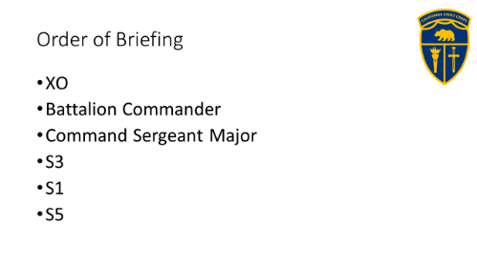
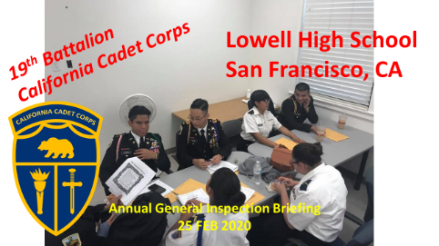
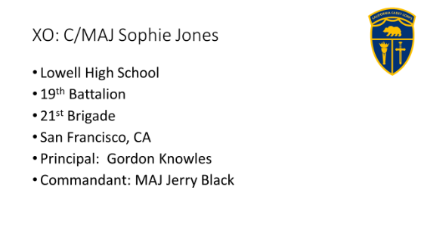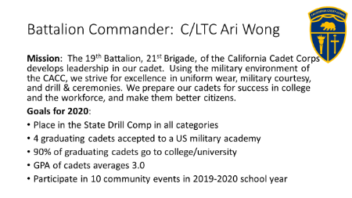

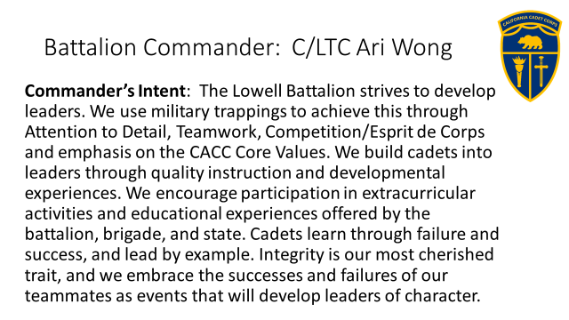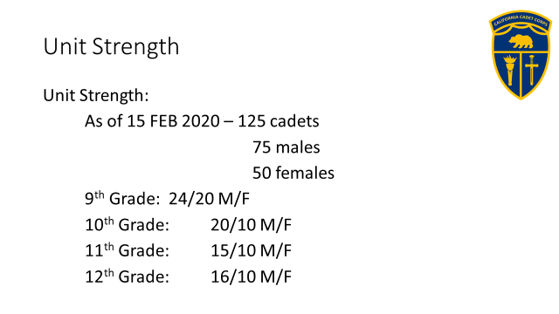

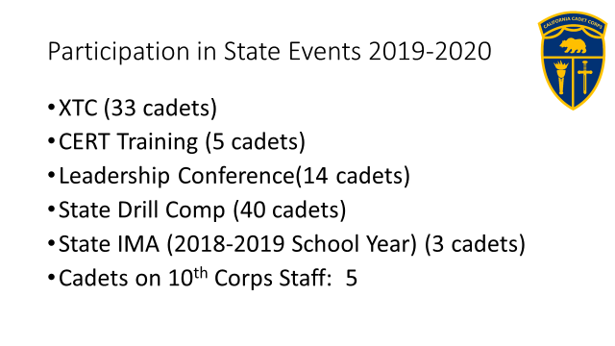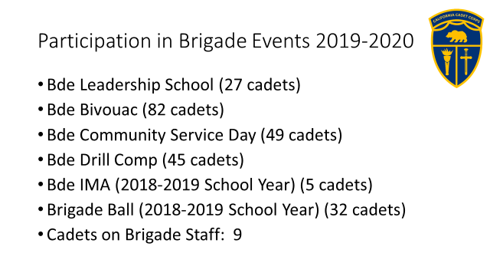

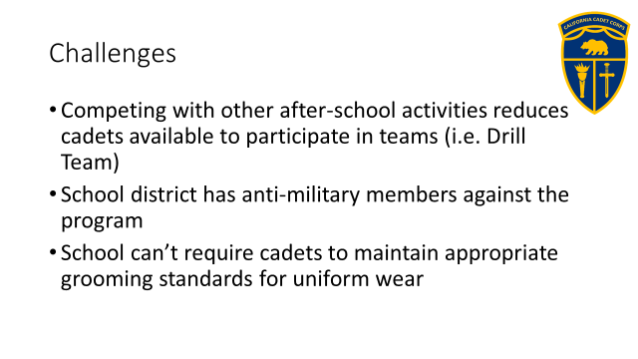

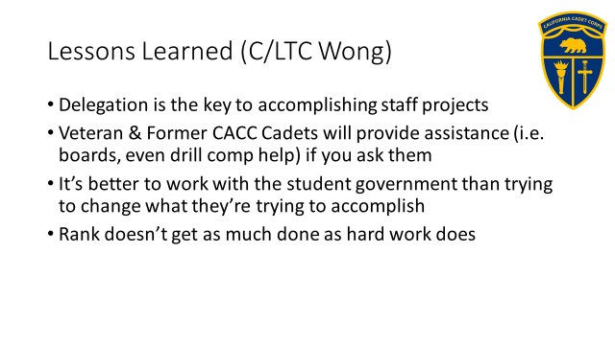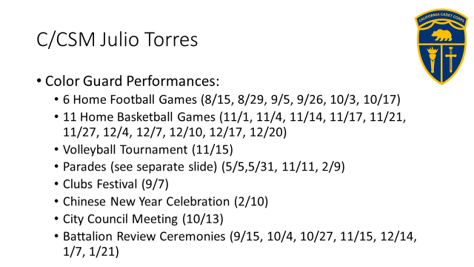

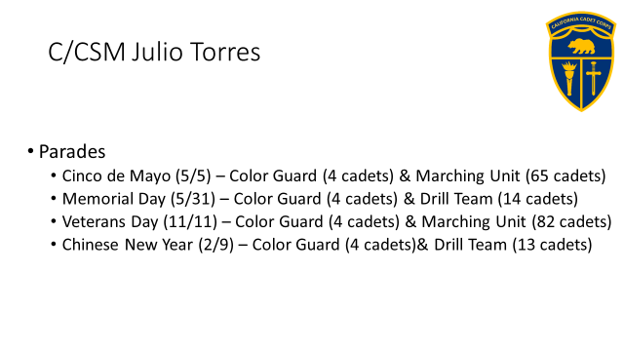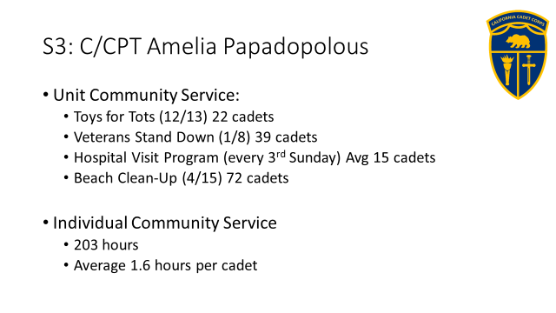

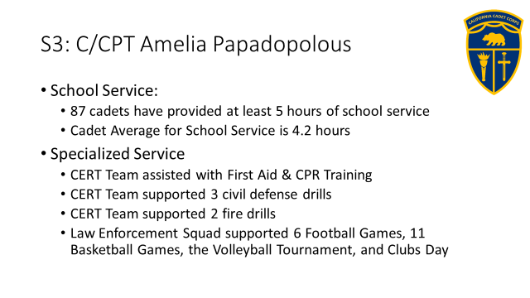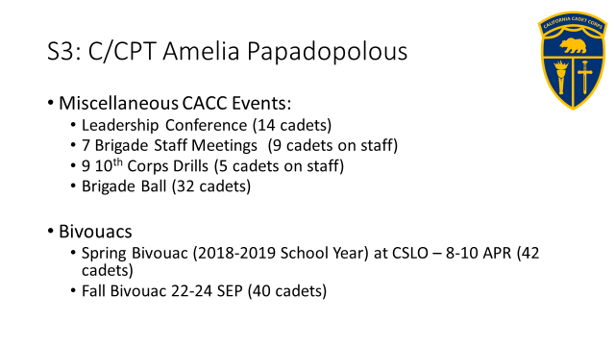

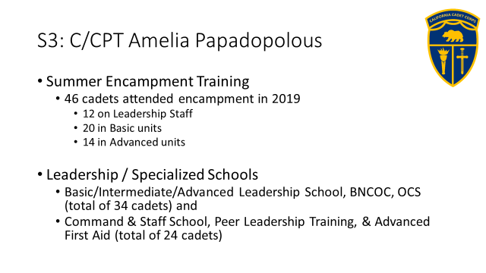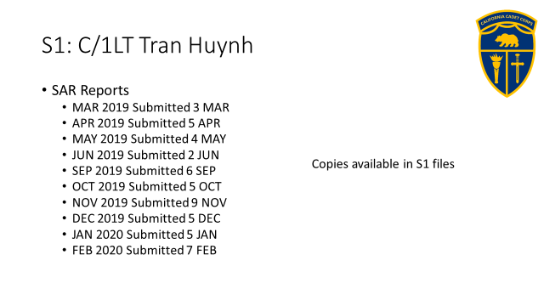

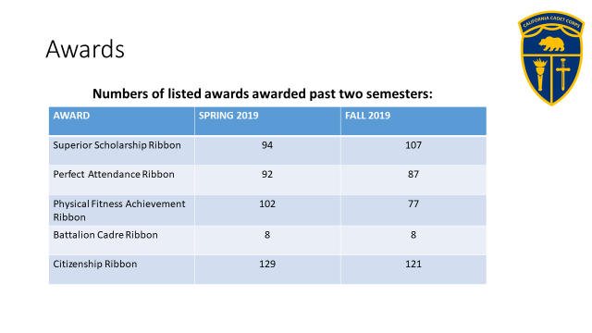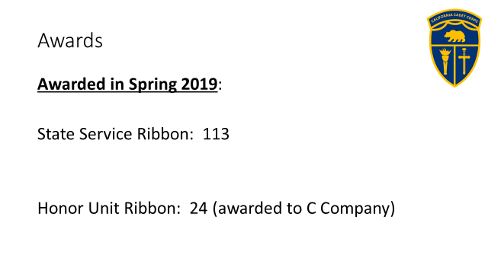

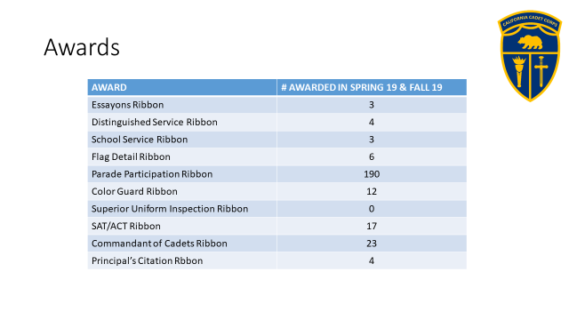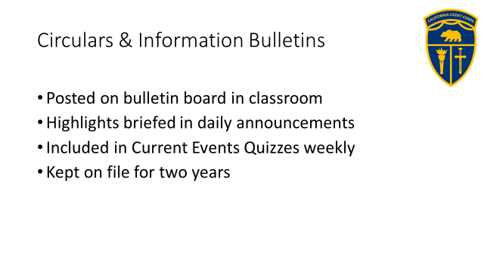

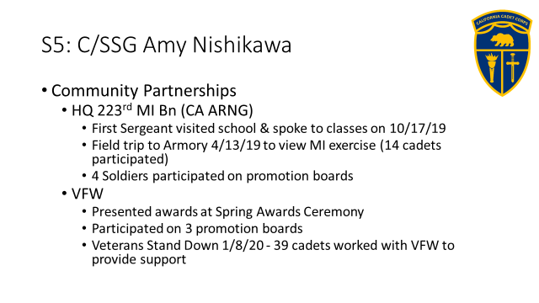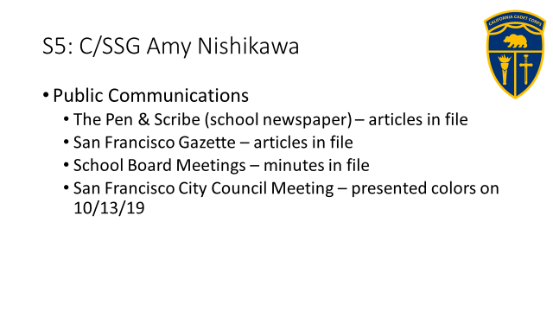

CR 1-9 outlines the CACC program in schools, what the school needs to provide, and what the CA Military Department or Cadet Corps can provide to a school starting up a new program. Much of this is going to be situationally dependent on current budgets at the school and Military Department.

B2. Safety (S-2) Regulation CR 2-1
There is only one regulation that falls under the oversight of the S2 (Safety & Security Officer), CR 2-1, Safety, Risk Management, Environmental & Cadet Protection. The subjects listed in the title are well outlined in the regulation. All are important aspects of the general subject of Safety and keeping cadet operations safe and secure.

a. Safety. It is an expectation that safety training be incorporated into all CACC instructional standards. We teach cadets about the hazards present during training and how they can be mitigated and reduced. Almost all the training we conduct in the Cadet Corps encounters some type of hazard, and it is a leader’s (and all cadets’) responsibility to note hazards and work to ensure they don’t cause the injury, illness, or damage they are capable of. The major common hazards are dehydration, cold and heat injuries, horseplay, uneven terrain, hygiene and sanitation issues, and medical issues. The Cadet Corps uses the Army’s risk assessment process to identify, assess, and reduce the effects of hazards through focus of leaders and cadets.

b. Risk Management (RM). RM is the process of identifying, assessing, and controlling risks arising from cadet activities, and making decisions that balance risk costs with mission benefits. There are five steps in the process:

(1) Identify hazards
(2) Assess hazards to determine risks
(3) Develop controls and make risk decisions
(4) Implement controls
(5) Supervise and Evaluate

During the risk management process, leaders combine the probability of the hazard occurring with the severity of the threat if it does occur. The leader can then impose control measures that will reduce the risk, and make an informed decision as to whether the risk is reduced to an acceptable level or controlled completely, and whether or how the training or operation will occur. The higher the risk level, the higher the level of commander (e.g. commandant, brigade advisor, XO) is needed to approve the training plan.

PROBABILITY→  SEVERITY↓ | FREQUENT | LIKELY | OCCASIONAL | SELDOM | UNLIKELY
CATASTROPHIC  (death/serious injury and/or environmental damage) | Extremely High | Extremely High | High | High | Moderate
CRITICAL (extensive injuries and/or environmental damage) | Extremely High | High | High | Moderate | Low
MARGINAL (minor injury/illness/environmental damage) | High | Moderate | Moderate | Low | Low
NEGLIGIBLE (first aid, very minor loss) | Moderate | Low | Low | Low | Low

c. Environmental. Cadets and adult members of the California Cadet Corps have a responsibility to be good stewards of the earth. At no time should a cadet activity leave our planet in a worse condition than when that activity began. The CACC environmental policy has three principles:

Principle #1. Cadets will always leave an area better than when it was found.
Principle #2. Cadet Corps leadership will be familiar with applicable local, state, and national policies regarding environmental impact and fully comply with those policies.
Principle #3. Cadet Corps activities will strive to mitigate any negative impact on the environment and will, whenever possible, avoid such impact.

d. Cadet Protection. The Cadet Protection Policy sets out rules and guidelines that drive the safety of cadets from abuse of any type and establishes a baseline for decorum (how cadets are required to behave in the CACC environment). The California Cadet Corps conducts its program in a positive, safe, age-appropriate environment that follows a military model emphasizing Cadet Corps traditions and values. Cadets have opportunities to lead, encounter challenges, and have fun as they work.

Commitment to Safety. CACC’s policy asserts that there is no place for physical, sexual, or emotional abuse in any of its programs. CACC will report to law enforcement all reasonable suspicions of child abuse and other criminal activity as required by local law and will cooperate with law enforcement investigations.

Scope. This regulation governs all participants in CACC activities conducted by HQs, CACC and applies to all CACC members, cadets and commandants, adult volunteers, chaperones, and any nonmembers who may have any interaction with CACC cadets. When non-CACC members (such as guest speakers, military personnel, trainers, or visitors) interact with cadets, CACC members will supervise to ensure that the non-CACC adults adhere to basic, socially acceptable norms. Non-members who are working with cadets (i.e. military members, school chaperones) will be briefed on this policy prior to working with cadets.

At CACC events co-sponsored by HQs CACC and local school districts, the more restrictive of the Cadet Protection Policy or the district policy shall apply and must be complied with. Adults from the local school district (i.e. chaperones, Commandants, or supervisors) are responsible for being familiar with, and ensuring compliance with local policies relative to cadets from their respective districts.

Some key aspects of cadet protection are outlined as universal standards of practice:

a. Proximity of Supervisor. Because each physical environment, mixture of cadets’ grades and ages, and nature of activity is different, CACC does not set a firm rule regarding the proximity between a group of cadets and their adult supervisor. If supervisors do not have direct line of sight contact with cadets, they must nevertheless be aware of where the cadets are, what they are doing, and check up on them periodically. For example, a cadet unit may practice drill in the parking lot while the adult supervisor remains in the barracks, but the unit may not leave for dinner at the DFAC without the adult supervisor.

b. Semi-Private Discussions. Adult supervisors who need to mentor or counsel cadets individually during official activities should do so in the presence of a third person when reasonably possible.
Alternatively, one-on-one meetings are permitted but not recommended if conducted in a semi-open setting (e.g. office door kept open, or conversing away from, but in sight of, the group, or other circumstances). Cadets are prohibited from meeting one-on-one in a closed environment; an adult leader must be present or other arrangements must be made to minimize the risk of misconduct, such as keeping the door fully open.

c. Transportation. If an adult leader transports cadets other than his or her family members to, from, or during a CACC activity, the party must number at least three (adult driver plus two cadets; or adult driver, second adult, and one cadet). Exceptions to this policy may be granted by the CACC XO if parental/legal guardian permission is attained. In emergency situations, this rule may be waived if the cadet needs to be driven to get medical care; the officer in charge will make the call to waive the three-person requirement, including consideration of having another cadet or adult accompany them to watch over the patient.

d. Field Conditions. Cadets will observe the rule of three when out in the field. They may be separate from adult supervisors in a controlled situation such as land navigation courses and survival as long as they have a method of obtaining adult assistance. It is preferred that cadets stay in groups of four so two can go for help and one can stay with an injured cadet in case of emergency.

e. Favoritism and Gifts. Showing favoritism and receiving gifts from cadets connotes quid pro quo regardless if this is the intent and therefore is strongly discouraged. It breeds resentment and adversely effects morale, esprit de corps, and the ability to train effectively. Because of the leadership training model of the CACC, promotions and awards come from performance and are considered appropriate without the perception of favoritism. Conversely, there are appropriate consequences for poor performance that are used to influence better performance and behavior within the CACC training concept. Both adult and cadet leaders will ensure that promotions/awards and/or consequences for poor performance do not present the appearance of favoritism.

f. Social Media. Prior to posting anything on social media sites regarding HQs CACC events, the poster will coordinate with the CACC S5.

g. Adult Supervisors’ Quarters. No adult supervisor will lodge in a tent or barracks room with a cadet who is not a member of his or her immediate family. There will be an adult supervisor assigned to monitor cadets in the barracks after lights out. When facility limitation requires that adults and cadets be housed in the same room/bay, they will be separated as much as possible, and this is never acceptable for just one adult and one cadet.

h. Segregation by Gender. Male and female cadets will be assigned to separate quarters. Adult supervisors will establish clear guidelines as to when and how personnel of one gender may enter areas designated for personnel of the opposite gender.

i. Transgender Cadets. The California Education Code Section 220 prohibits gender identity discrimination against students in educational programs and activities. The CACC shall make reasonable accommodations for any transgender cadet that wishes to participate in activities as facilities are available.

j. Personal Care Time. CACC will respect cadets’ reasonable expectations of privacy during times designated for sleeping, dressing, and showering. If all participants share a single shower facility, adult supervisors and cadets will use the showers at separate times, and the ranking cadets will maintain good order in the shower area. Adult supervisors are not to enter the cadet shower and latrine areas during personal care time except in case of emergency. Photography and recording are strictly prohibited in the shower and latrine area. Devices that have cameras are prohibited from the shower areas and must be stowed away when cadets are undressing in the dorm or barracks area.

k. Confidentiality. CACC cadets and adults will respect a broad right to confidentiality of all event participants regarding medical and health information. Such information will only be shared on a “need to know” basis to protect the health and wellness of the cadet, and then only the information required for appropriate care of the cadet will be shared. Except as provided by law, parents will be privy to all medical and health information of their respective cadets, which will typically be shared by adult medical or mental health staff with the parents.

l. Training. Adult and cadet leaders participating in cadet training or activities that extend beyond two nights (ex. Summer Leadership Camp, Advanced Camp, etc.) shall require a briefing that reviews the cadet protection concepts identified in this regulation. Topics in the briefing should include identifying abuse and hazing, appropriate training and intensity levels for cadet activities, how to report violations of the policy, fraternization, and appropriate decorum during the event.

Any suspected violation of the Cadet Protection Policy will be reported up the chain of command. Any leader, Chaplain, or Inspector General, may receive a report. They will, in turn, report it to the CACC Executive Officer.

B3. Operations (S-3) Regulations
There are several CACC Regulations that deal with training issues.

a. CR 3, California Cadet Corps Training
is the regulation that outlines the overall structure of the CACC Curriculum. It explains how Applied Leadership works within the Cadet Corps construct and discusses the different ways the academics of the program may be taught, depending on the school. This is discussed in Section C of this strand. It is an important regulation for Cadet Staff in that it covers lesson planning, training schedules, and cadet knowledge.

Appendix C gives a template that can be used for lesson planning. This is particularly useful to cadet leaders who are tasked with the opportunity of teaching academics to the more junior cadets.

Appendix D gives the Cadet Corps template for Training Schedules. The Cadet S3 and his/her staff play a significant role in publishing the training schedules for the unit throughout the year. The template allows them to focus on what’s important about training schedules: getting the plan right. The Training Schedule allows the Commandant to work with the S3 to synchronize the training for the unit, including who the trainer will be.

CALIFORNIA CADET CORPS TRAINING SCHEDULE
UNIT: _____504th Bn__ |  |  |  |  | DATES: ___20-25 AUG 2018___________________
DATE/TIME | WHO | WHAT | WHERE | TRAINER | UNIFORM | NOTES | CACC STD/ STRAND/LESSON
8/20/2018 Pds 2/3/4 | 1st Yr | Class: CACC History & Organization | CR 201 | C/SFC Jones | None |  | Std 1. M5/A1 & A4
8/20/2018 Pds 2/3/4 | 2d Yr | Class: Teaching Drill | Drill Pad | C/1SG Diaz | None | Bring TC 3-21.5 | Std 1. M7/A1 & A2
8/20/2018 Pds 2/3/4 | Sr Cdts | Self-Study: Leadership Styles | CR 202 | C/MAJ Scanlon | None |  | Std 3. L4/A1-4
8/21/2018 Pds 2/3/4 | ALL | D&C: Ind Drill | Drill Pad | Sqd Ldrs | None | Fall In, Attn, Facing | Std 1. M3/B
8/22/2018 Pds 2/3/4 | ALL | Uniform Issue | CR 201 | C/2LT Smith | None | Class B & C
8/23/2018 Pds 2/3/4 | 1st Yr | Class: Class B Uniform | CR 201 | C/2LT Smith | None |  | Std 1. M2/A
8/23/2018 Pds 2/3/4 | 2 & 3d Yr | Practice: Teaching Drill | Drill Pad | C/1SG Diaz | None | Individual Drill Movements | Std 1. M3/B
8/24/2018 Pds 2/3/4 | ALL | PT: Extended Rectangular Formation | Field | C/1SG Diaz | None | PT Clothes | Std 4. W3/B2
8/25/2018 Pds 2/3/4 | ALL | D&C: Ind Drill | Drill Pad | Sqd Ldrs | None | Facing, DRD/Cover/ Open Ranks | Std 1. M3/B
NOTES: Staff Requirements: S1 start Personnel Files; S3 finalize Training Schedules & File Lesson Plans; S4 Issue Uniforms; S5 Market to get late registering students into CACC.
APPROVAL
Initial/Date: Cdt Tng Off: ____________________ Cdt Cdr: ____________________ Commandant: _________________________
CACC Form 23 (Jul 2018) Previous editions are obsolete

The CACC curriculum model gives a recommendation down to Lesson of what should be taught at each level through the first four Cadet Corps semesters. This is a generic model – the Commandant and S3 must determine what works for their program based on the situation within their battalion and the Battalion Commander’s Goals and publish a Training Schedule that accomplishes those goals. They should also consider the cadet promotion system, and what cadets need to know to be promoted. Commandants don’t need to teach all the information needed for promotion – Cadets can do some self-study, but much of the information in the promotion system is basic information cadets should know, and therefore likely going to be information the Commandant will want to teach to first year cadets. Finally, the Commandant and S3 need to have a plan on how the non-first-year cadets will continue to learn from the curriculum. This is generally a mix of involvement in teaching first-year Cadets, group and self-study of curriculum material, and leadership and staff positions.

CR 3 provides the “Cadet Corps Knowledge” that is expected of a successful Cadet. This includes:
- The CACC Mission, Goals (Cadet Code), and Objectives
- The CACC Core Values, Honor Code, Definition of Leadership, & Leader’s Code
- CACC History and General Orders
- CACC Chain of Command

b. CR 3-14, Cadet Activity Planning
is the regulation that outlines a process and format for planning activities within the Cadet Corps. Planning is a skill leaders need to develop and practice, and CR 3-14 gives senior cadets and commandants a context within which to plan activities and grow as leaders. CR 3-14 introduces the Cadet Activity Planning Process (CAPP) and a Planning Checklist that gives leaders a tool to guide their planning. CR 3-14 also gives the formats for and explanation of the Army type orders we choose to use: The Operations Plan (OPLAN), the Operations Order (OPORD), the Warning Order (WARNORD), and the Fragmentary Order (FRAGORD). CR 3-14 gives everything leaders need to plan activities!

The Cadet Activity Planning Process:
Step 1: Envision the Activity
Step 2: Initial Planning
Step 3: WARNORDRD/Marketing/Staff Selection
Step 4: Detailed Planning
Step 5: Support Planning
Step 6: Preparation
Step 7: Execution
Step 8: Assessment

B4. Logistics Regulation: CR 4-1, Supply Management

The Cadet S4 (Supply and Logistics Officer) and his/her staff have primary responsibility to implement the procedures outlined in CR 4-1, Supply Management, under the supervision of the Commandant. All cadets should be at least somewhat familiar with CACC Form 100, the Individual Clothing Record, enough to be able to review it for accuracy when they sign that they receive uniform items.

The Cadet S4 Staff will use CR 4-1 to establish and use proper procedures to account for the property under their custody. This lesson will briefly cover the concepts the S4 Staff are expected to understand and use.

The primary principle behind supply operations is accountability. Accountability is the process of knowing exactly what supplies and equipment (including uniforms) the unit has on hand, and exactly what is issued to whom. It includes written tracking of the issuance of supplies and equipment, and the retrieval of equipment when a cadet leaves the CACC program or unit. The S4 Staff is also responsible for planning the logistics aspects of activities (i.e. what supplies and equipment will be needed to support planned training and participants), but that is not a part of this lesson.

There are two types of equipment found at a unit: State Controlled Items and Quick Service Items. This equates to what is called Durable Property and Expendable Property in the Army supply system. State Controlled Items are things that MUST be accounted for and are strictly controlled. These include weapons, uniform items, CPR mannequins, compasses, or color guard equipment. If they are lost, the unit that had the item must complete a Report of Survey to account for its loss. Quick Service Items, such as rank insignia, ribbons and medals, attachments, do not have to be strictly accounted for. They may be issued to Cadets and not collected back. Units will, nonetheless, control these items in such a way that they are not pilfered or received by unauthorized personnel.

Each unit will maintain a CACC Form 100, Individual Clothing Record, on every assigned cadet who has been issued Cadet Corps supplies. CR 4-1 explains how the form is filled out and gives samples of completed forms. The key to success with accountability is that EVERY TIME you issue a uniform item to a cadet, or receive an item back, it goes on the CACC Form 100. Any other items given to cadets or anyone else, if they leave the place they are stored, should be annotated on a temporary hand receipt, or CACC Form 101. That just ensures you don’t lose track of things. When the item is returned, the Form 101 is no longer needed and destroyed. A good example of this is color guard equipment. If you establish a culture of accounting for equipment instead of just passing it around, you won’t lose it.

A Property Book is a legal record of the state-controlled items that a unit has been issued. It is kept on CACC Form 104 (electronic version). The Property Book lists what you should have on hand based on what the unit has received or purchased, and what has been issued out. You must have CACC Form 100s in your files that, when audited, add up to the numbers on your CACC Form 104. You can then use the information on the Form 104 to inventory the stock you have in your Supply to ensure all items are accounted for. Units are required to conduct an inventory at the beginning and end of the school year and prior to the Annual General Inspection. If your inventory does not match what’s on your Property Book, you reconcile your numbers, investigate to determine where the discrepancies are, and try to recover the missing items. You must complete a Report of Survey (CACC Form 51) if you’re still missing items, and try to explain the loss. In the Army, whoever is signed for the lost equipment usually has to pay for it unless they can show the loss is not their fault. In most cases in the Cadet Corps, we cannot force cadets or even their parents to pay for lost items, though schools can require the parents to replace the items if they are commercially available. The only way to remove the item from your Property Book is to have a completed Report of Survey that has been approved by the CACC State Headquarters on file – that authorizes the change to the official numbers in the Property Book.

The other forms prescribed in CR 4-1 are used to request supplies from the State Headquarters. These are obsolete and the reg will eventually be updated. Requisitions are done with online forms on the website. They are filled when supplies are available.

B5. Civic, Public & Military Affairs (S-5) Regulation, CR 5-1
describes the policies and procedures to be used to inform and promote positive and appropriate relationships with Civic, Public, and Military (CPM) activities of the California Cadet Corps. Much of CR 5-1 describes responsibilities of adults, but CPM is a critical staff responsibility that can make or break a cadet unit, and the Cadet S5 is a key provider of support to our CPM activities. Cadets are our best ambassadors and should be out front in selling the Cadet Corps to other students, school administrators and teachers, and civic, public, and military representatives.

Paragraph 1-6 of CR 5-1 has a great summary of the general provisions for CACC CPM activities:

a. The California Cadet Corps does not discriminate on the basis of sex, race, creed, color, sexual preference, or national origin. As such, cadets, commandant personnel, and units of the California Cadet Corps will not participate in or actively or tacitly support the activities of any person or organization or any events that discriminate for any of these reasons.

b. Members of the California Cadet Corps will not participate as representatives of the California Cadet Corps in events or activities that selectively benefit, or appear to selectively benefit any person, group, or corporation (whether profit or nonprofit), religion, sect, religious or sectarian group, or quasi-religious movement, ideological movement, or political campaign. This does not preclude members of the CACC from participating in events or activities at locations such as houses of worship, shopping malls, airports, or conventions provided the activities do not appear to endorse that person, group, or corporation (whether profit or nonprofit), religion, sect, religious or sectarian group, or quasi-religious movement, ideological movement, or political campaign.

c. California Cadet Corps equipment, logistical support, and personnel may not be utilized for CPM activities which involve (or appear to involve) the endorsement, promotion, or sponsorship of any private individual, group, organization, or venture.

d. CACC support may be provided to non-partisan events sponsored by fraternal organizations, government entities, schools, civic or veterans’ organizations, or organizations whose primary purpose is fostering public service, stimulating patriotism, promoting understanding of national security issues, or fostering appreciation of our national heritage.

e. The California Cadet Corps will encourage its members to actively participate in service activities benefiting the schools and communities in which they live. Such service should advance the common good and not be in poor taste or promote ideals contrary to the mission, goals, and objectives of the California Cadet Corps. Cadets should never be used in capacities that appear demeaning or inappropriate.

f. Cadets performing service or other activities in their official role as members of the CACC may not receive remuneration for services except as permitted by law or local school district policy. Nothing in this regulation shall be construed to prohibit individual CACC members from volunteering their private support to charities of their choice.

g. CACC members may not participate in community relations events or programs in which a public confrontation is planned or likely (or where the apparent purpose is to stage controversy).

Every effort will be made by units, regiments, brigades, and the HQ, CACC to promote positive relationships with:
- civic entities, including but not limited to:
- city council members
- mayors
- city departments/agencies
- school board members
- school district officials
- county supervisors
- county government offices/agencies
- the state assembly
- the state senate
- The California Department of Education and California State Board of Education
- The Governor, Lieutenant Governor, and other elected statewide officials
- Other State of California departments/agencies

The unit S5 Staff will:
- Send invitations to civic dignitaries to events which their participation would be appropriate.
- Involve civic dignitaries in award presentations.
- Request proclamations from civic government entities acknowledging the CACC Birthday on April 5th, to be presented in a suitable ceremony attended by dignitaries.
- Seek membership or participation in local civic commissions, boards and committees that address topics of special interest to the CACC, giving input that will influence decisions positively for the CACC program and our values.
- Work with the Battalion Commander and Staff to have the unit participate in local parades.
- Conduct a Flag Disposition Ceremony annually as described in CR 5-1.
- Seek out opportunities to perform Color Guard and Flag Details at city hall, city council, meetings, school board meetings, county board of supervisor meetings, and other civic meetings
- Publish newsletters and web pages informing cadets, parents, school faculty and the public informed of CACC happenings.
- Reach out to local fraternal and service organizations such as the Veterans of Foreign Wars (VFW), the American Legion, Lion’s Club, Rotary Club, Toastmasters, the Fraternal Order of Eagles, the Elks Club, the Odd Fellows, Jaycees, Kiwanis Club, etc. It is entirely appropriate for the CACC to perform service with and for these organizations as resources permit. They are outstanding sources of judges for unit competitions, promotion boards, and review ceremonies. They may provide scholarships to Cadets to attend activities. Their meetings are good venues for cadets to deliver speeches regarding the Cadet Corps and seek needed support for the unit.

Cadet Corps units are encouraged to seek partnerships with local military units, whether California National Guard (Army or Air), Army, Navy, Air Force, Marine Corps or Coast Guard Reserve, or active duty bases near Cadet Corps schools. Relationships should go both ways – determine how the local unit and the CACC unit can work together, support each other, or use facilities. Local military personnel can augment the Commandant providing instruction in class, after school, or during weekend activities (ensure school rules for outside instructors are followed!). The S5 should interact with the local unit personnel, under the supervision of the Commandant, and request their support, or offer a venue where the CACC unit can assist the military unit. Some ideas are helping serve at unit holiday parties, washing military vehicles, or even acting as role players in military unit training events.

Cadet S5s are often the designated photographer at CACC events. We want to encourage taking photos of events that the unit can use to show their level of activity and professionalism, and as memories. Cadets should be given a waiver for their parents to sign if you are going to use the photos in public. Make sure the Commandant or the State S5 pre-approves any photos before they are posted to social media. Your best photos should be shared with the CACC State S5 so they can be loaded onto our Flickr page and used for CACC publication.

When at all possible, have cadets represent the California Cadet Corps. Whether it is providing a color guard, speaking to a civic group, addressing the Board of Education, or meeting an Assembly member, cadets make the most impact. Commandants should facilitate their cadets interacting (as necessary), and coach them, but should allow cadets to be the face of the Cadet Corps.

