CURRICULUM ON MILITARY KNOWLEDGE
  - Strand M1: Cadet Regulations
  - Level 11
This Strand is composed of the following components:
- Core Cadet Regulations
- Cadet Staff Regulations
- Regulations that Guide Us

Table of Contents
C. Regulations that Guide Us 3
Objectives 3
C1. Personnel Regulations (S1) 4
c. CR 1-9, Establishing a Cadet Corps Unit 6
d. CR 1-12, California Cadet Corps Organizational Colors and Guidons 6
C2. Operations (S-3) Regulations 7
a. CR 3, California Cadet Corps Training 7
b. CR 3-1, Leadership Training Schools 8
c. CR 3-2, Field Training 8
d. CR 3-3, Summer Camp 8
e. CR 3-4, Individual Major Awards 8
f. CR 3-8, Competitive Drill 9
g. CR 3-12, Physical Fitness 9
h. CR 3-17, Rifle Marksmanship Training and Competitions 10
i. CR 3-22, California Cadet Corps Organization 10
C3. Logistics: CR 4-2, State Property 10
C4. CR 3-21.5 Drill & Ceremonies 11

C. Regulations that Guide Us

Objectives

DESIRED OUTCOME (Followership) / PRACTICUM B
90% of Cadet Leaders are able to identify where to get information about the standards established by California Cadet Corps Regulations that provide general guidance about a variety of subjects.

- Use CR 1 to properly prepare a memo or letter
- Identify the major requirements from CR 1-9 to establish a new Cadet Corps unit
- Identify the specifications for flags and guidons per CR 1-12
- Describe the Cadet Corps Curriculum system of Core Instructional Groups, Strands, Sections, and Lessons. Given a topic, find it within the list of lessons
- List the Leadership Training Schools as described in CR 3-1
- List the Field Training conducted within the CA Cadet Corps per CR 3-2
- Describe the CA Cadet Corps Summer Encampment program per CR 3-3
- Describe the Individual Major Awards (IMA) program per CR 3-4
- List the divisions and events within the CA Cadet Corps Drill Competition program per CR 3-8
- Describe the Fitnessgram as implemented by the California Cadet Corps in CR 3-12
- Describe the Marksmanship Training and Competition program as described in CR 3-17
- Describe the three chains of command identified in CR 3-22 for use within the CA Cadet Corps
- Use CR 3-22 to determine promotion eligibility of a cadet in a staff position in battalion, brigade, or state level units
- Using CR 4-2, describe the security required for state equipment stored at schools
- Use CR 3-21.5 to determine standards for performing Drill and Ceremonies at individual, squad, platoon, company, or battalion level
- Use CR 3-21.5 to determine standards for rifle drill, manual of the guidon, and color guard drill
- Use CR 3-21.5 to properly plan a review ceremony at battalion or brigade level

Note: When reviewing each of the regulations listed in this Section, cadets should acquire and review the regulation itself in addition to the curriculum text and slides

C1. Personnel Regulations (S1)

We covered most of CR 1 in Lesson B (Cadet Staff Regulations), as much of its content applies to what the S1 needs to do to manage personnel actions and records. But we left off the section in CR 1 that covers preparing and managing correspondence, as that part is not just for S1 staff, but for all Cadet Corps personnel who ever prepare a memo or letter.

The guidelines for correspondence are taken from, and try to stay very similar to Army guidelines on correspondence. Like with many things in the military, they provide very specific guidance on how you’re supposed to do it. You don’t wear an insignia an inch away from the pocket if the regulation says it’s supposed to be half an inch, and you don’t separate paragraphs in a letter by three spaces if the regulation says it’s supposed to be two spaces. You need to study CR 1 when you are preparing correspondence, and ensure you are paying attention to detail in determining how to write it.

Preparing and Managing Correspondence.

Following the Army’s system, there are different types of correspondence, and each has a specific purpose and format. They are the Letter, the Memorandum, the Information Bulletin, the Circular, and the Letter of Instruction. Warning Orders, if published by cadet staff for activities or events, may be considered a Circular.

Letter | For communicating with civilians outside the CACC (parents, school district officials, civic & government entities)
Memorandum | For communicating with CACC or military members or offices. Includes Memorandum for Record (MFR), Memorandum of Agreement (MOA), or Memorandum of Understanding (MOU)
Information Bulletin | Published announcements put out on a regular basis. HQ CACC publishes monthly Info Bulletins to convey information to CACC members
Circular or WARNORD | Gives directions and information about a specific event or operation (i.e. Drill Competition, XTC, Leadership Conference). May be in a Circular or WARNORD format.
Letter of Instruction | Communicates policy, directives or instructions

When sending correspondence up or down a chain of command, it may go through the chain – e.g. State sends correspondence to a Brigade, who then sends it to a Battalion, potentially attaching brigade guidance on to the original correspondence via use of a memo or endorsement. Another option may be used if the intermediate headquarters doesn’t need to staff additional guidance; the State may send correspondence directly to a battalion (or vice versa); in this case, the state will furnish a copy to the intermediate headquarters so they are aware of the correspondence (“cc” stands for carbon copy, the old fashioned way of doing this, and still called a “cc” even on computers).

The Army has a published style of writing they want us to follow. It is direct and clear and gets to the point quickly. Army writing avoids using the passive voice (e.g. instead of saying “in-processing will be conducted by the S1 starting at 0800”, you say “the S1 will start in-processing at 0800”). Use short words, keep sentences short, and keep correspondence as brief as possible while still giving needed details.

When using acronyms in any document except the most informal of emails, use the full text in its complete form, put the acronym in parentheses after the text. You may then use the acronym throughout the remainder of the document (e.g. The California Cadet Corps (CACC) is an organization that falls under the California Military Department (CMD). The Executive Officer (XO) of the CACC reports to the CMD on a regular basis, and receives direction from the Commander, Youth and Community Programs Task Force (YCPTF). Use military and civilian acronyms sparingly and only if you are sure the reader will be familiar with the use.

Correspondence, except for informal memos and emails, uses the CACC letterhead as described in CR 1, paragraph 5-1f and Figure 5-1. Documents are typed using Arial font, size 12.

Office symbols show the office a piece of correspondence originates with, and who it is addressed to. An office symbol starts with the organization (e.g. CACC HQ or 2nd Brigade or 97th Battalion). The next part of the office symbol is the staff section symbol (e.g. SPO for Special Projects Officer, S-1, or PS for Platoon Sergeant). The platoon sergeant of first platoon of Charlie Company of the 97th Battalion would use CACC-97-C-1-PS. The Executive Officer of 5th Brigade would use CACC-5-XO.

You use an Authority Line when you prepare and sign a document on behalf of someone else, under the delegated authority of that person. A staff officer/NCO usually writes correspondence under the authority of the commander (if it relates to their staff function). The S1 would use an authority line when writing to units about the SAR. But if the S1 writes a letter of recommendation for a cadet he knows, he would not use an authority line. Cadet Corps members use authority lines based on who their commander is:

Battalion/Brigade/Corps Staff Officer/NCO | FOR THE COMMANDER
Assistant Commandant | FOR THE COMMANDANT
Brigade Support Team Member | FOR THE BRIGADE ADVISOR
State Staff Officer/NCO | FOR THE EXECUTIVE OFFICER

The Signature Block is the name, rank, and position of the writer of the correspondence. The name and rank are in capital letters, and used the approved acronym for the rank (except in letters, where the rank is spelled out because the letter goes to civilians who don’t know rank acronyms). The organization is always CACC, unless referring to rank/status in another organization (e.g. CPT, USAR for a Captain in the Army Reserve who is writing as a CACC member). The title is your position in the organization (you don’t need to repeat the name of the organization – it is in the letterhead and office symbol).

Cadet: Commandant:

JOHNNY K. DETT JOHNNY P. JONES
C/SSG, CACC 1LT, CACC
Platoon Sergeant Assistant Commandant of Cadets

Details for the different types of correspondence, and formats, are in CR 1, chapter 5, and in examples in Appendices E through I. Ensure you use the correct margins, spacing, style of address, font, etc. that are designated in CR 1.

c. CR 1-9, Establishing a Cadet Corps Unit
is the regulation that tells us how to start up a new CACC unit. It’s not something many cadets get involved in, but there are times when cadets work to set up a unit at their school, or at another local school. The critical elements is to have Principal and School Board approval, identify a Commandant who can teach the program, and have enough cadets interested to start up a unit (ideally, at least 30).

CR 1-9 outlines the CACC program in schools, what the school needs to provide, and what the CA Military Department or Cadet Corps is able to provide to a school starting up a new program. Much of this is going to be situationally dependent on current budgets at the school and Military Department.

A key point of the program establishment process is that the Commandant is an employee (paid or unpaid) of the school, and the Military Department is not involved in the hiring process. CACC provides a program with standards, curriculum, and activities, but the program is run by the school under the supervision of the Principal.

The Brigade Advisor and personnel at Headquarters, CACC assist the school in the establishment process by providing guidance and information, equipment, and by supporting the process of adding the school and commandant to the Cadet Corps.

d. CR 1-12, California Cadet Corps Organizational Colors and Guidons
is the regulation that gives us the standards for CACC organizational colors (the CACC flag) and guidons. If you’re ordering a new flag or guidon for your unit, you need to ensure what you order meets these standards. The regulation establishes the size and colors, where the numbers are placed and what numbers or letters are used, and how the flag is carried. It also describes the streamers that can be carried with the guidon and their standards.
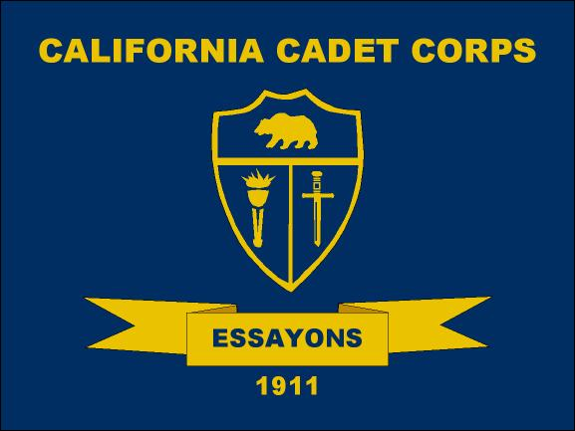

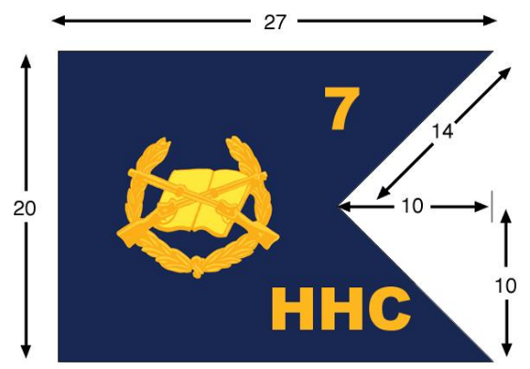

Flags will either be four-foot four-inch hoist by five-foot 6-inch fly OR three-foot hoist by 4-foot
fly. CACC organizational colors should never be displayed or carried with National or State Colors that
are larger in dimension.

C2. Operations (S-3) Regulations
There are several CACC Regulations that deal with training issues.

a. CR 3, California Cadet Corps Training
is the regulation that outlines the overall structure of the CACC Curriculum. It gives guidelines on how Applied Leadership works within the Cadet Corps construct, and discusses the different ways the academics of the program may be taught, depending on the school.

CR 3 outlines the structure of the CACC Curriculum, including the four Core Instructional Groups (Military Subjects, Citizenship, Leadership, and Wellness). Each of these groups is further divided into Strands – a single subject of instruction. Each Strand has three (there may be a few with two or four) Sections that help organize the Strand’s subject matter into more learnable categories. The Sections, lettered A, B, and C for each Strand, are in a general way categorized as beginning, intermediate, and advanced (or sometimes Self-Mastery, Followership, and Leadership). Finally, each of these Sections has multiple lessons that contain the subject matter taught within the cadet program. Some lessons may be teachable in one sitting, where others are longer, requiring multiple class periods to cover the entire lesson.

CR 3 gives the Content Standards: statements of what students should know and be able to do within a particular subject area. These help us align our lessons with career technical education (CTE) or content standards for California public schools.

CACC uses a Flexible System of Curriculum. The Cadet Corps curriculum is complicated by the
fact that Cadets can begin the program anytime between the 5th and 12th grades, and may remain a
Cadet for as little as a semester or as long as nine years. The curriculum is therefore designed with flexibility in mind, and gives the Commandant complete control over what is taught, when it is taught, and at what level it is taught. How a school organizes its Cadet Corps experience has a lot of influence on how the Commandant structures the curriculum. In the end, the Cadet Corps provides a program that a Cadet can enter in 4th Grade and continue to progress and learn through high school graduation. Few cadets are able to remain in the program that long, as they transition from elementary to middle to high school, most districts don’t offer a progression of schools that all have a Cadet Corps program. But as we grow new schools, our goal is to add elementary schools and offer high schools where there are now only middle schools, and open programs in middle schools where there are now only high schools. Some military institutes are high school only, others are 5th through 12th grade.

CR 3 lists, in Chapter 6, the range of Cadet Knowledge and Basic Facts that cadets should know. This goes beyond the curriculum, which covers the many areas cadets may be taught. Cadet Knowledge is what Cadets should know – they should be able to recite the information presented in Chapter 6 during inspections or tests. This is also known in some circles as Memory Work.

The appendices in CR 3 give a detailed listing of the curriculum down to Section and Lesson (App A), a listing of the Strands and Sections that are recommended for each grade level (App B), a Lesson Plan Template (App C), and a Training Schedule Template (App D).

b. CR 3-1, Leadership Training Schools
is the regulation that outlines the various training schools that the Cadet Corps offers. This includes Leadership Schools (Basic, Intermediate, and Advanced), Non-Commissioned Officer (NCO) Schools (Basic and Advanced), Officer Candidate School (OCS), Specialized Training Schools, Drill Academies, Command & Staff Schools, and Commandant Professional Development Schools (Basic Commandant Training Academy, Advanced Commandant Training Academy, Commandant Leadership School, and other professional development opportunities).

For all these courses, CR 3-1 gives the purpose, objectives, authority, suggested curriculum, administrative procedures, and authorized awards

c. CR 3-2, Field Training
is the regulation that outlines the various types of field training that the Cadet Corps offers. This includes Bivouacs and Adventure Training, Mountaineering, and Survival Training. The regulation gives the purpose of the training, outlines the responsibilities of key personnel, gives the authority for conducting the training, and outlines the curriculum. There are extensive guidelines on cadet safety, and it outlines the awards available when you conduct this training. It also gives you forms containing standards and a checklist for mountaineering training certification and a special consent form required to be signed by parents.

d. CR 3-3, Summer Camp
is the regulation that outlines the summer encampment programs offered within the Cadet Corps. various types of field training that the Cadet Corps offers. This regulation includes the basic guidelines for the encampments, but each year decisions are made to enhance the experience for Cadets, so the regulation is really more of a guide than a strict script. The regulation discusses the purpose and goals for each of the programs offered, how they might be offered, and the strategy of having cadets fill the leadership positions that enable the activities to run smoothly, while giving Cadets an excellent leadership training opportunity. The regulation lays out the application process, which itself adjusts from year to year as we make improvements from lessons learned.

e. CR 3-4, Individual Major Awards
is the regulation that outlines the longstanding Individual Major Awards (IMA) program. The IMA program starts at unit level, with Cadets competing at unit, brigade, and state levels. IMA underwent a major change in 2019, but temporarily changed again in 2020 because of the Coronavirus Pandemic restrictions to in-person events. The regulation outlines the competition, within various categories defined by grade or school level (high school, middle school, or elementary school), with Cadets competing in areas that draw on what they’ve learned within the cadet program of the California Cadet Corps. Medals and ribbons are awarded to winners in each category, and the top student in the state level competition receives the Stilwell Saber. A major change occurred in the 2020-2021 school year, when the program was moved to the Fall so that winners in each category could participate in the California Military Department’s Servicemember of the Year Banquet & Awards Ceremony. This move brought cadets and the Cadet Corps closer to our parent organization, and gave cadet winners recognition at a much higher level.

f. CR 3-8, Competitive Drill
is the regulation that outlines the state level competitive drill program within the California Cadet Corps. The program in the regulation does not need to be followed in brigade drill competitions, but teams competing and winning at brigade level go on to the state competition. If the drill competition at brigade level is significantly different from that at state level, the brigade teams will not be as well prepared to succeed at state level as other brigades’ teams that use the formats in this regulation.

CR 3-8 establishes the different types of competition available for the 10th Corps to include in the Drill Competition. Teams are high school or middle school level, at squad or platoon level, and either armed with rifles or unarmed. There is also a competition for Color Guards, and for Exhibition Drill Teams of from four to thirteen Cadets. There may be a competition for guidon bearers. Finally, there is an Individual Drill Down with and without rifles.

CR 3-8 gives the drill command sequences for each category (except Exhibition Drill, which is up to the team to develop), and outlines how the competition is scored, along with the scoresheets that are used to judge the various aspects of the drill. It is specific as to how the competition will operate, size of drill pads, with guidance to the teams on how to form and dismiss their team on the drill pad, and uniform options allowed.

g. CR 3-12, Physical Fitness
is the regulation that outlines physical conditioning and fitness testing for Cadets. California schools and the California Cadet Corps use the Fitnessgram, created and published by the Cooper Institute, as the officially sanctioned California Physical Fitness Test (PFT). While California schools only administer the test in grades five, seven, and nine, Cadet units administer the test once each semester for all grades. The CACC PFT only consists of the mile run, the Curl Up, the Push Up, the Trunk Lift, the Sit and Reach, and the Shoulder Stretch.

Passing: “Passing” the California Cadet Corps PFT is defined as being in the Healthy Fitness Zone for ALL of the following:
a. Aerobic Capacity Test – The Mile Run; AND
b. Abdominal Strength and Endurance Test – The Curl Up; AND
c. Upper Body Strength and Endurance – The Push Up; AND
d. ONE or more of the three flexibility tests – Trunk Lift, Sit and Reach (Left AND Right), or
Shoulder Stretch (Left AND Right).

Chapter 2 of CR 1-12 gives an exercise regimen units can use to get Cadets in shape to take the PFT. It is recommended Cadets follow this regimen for at least two months prior to taking the PFT. Appendix B also gives “Get Fit” exercises Cadets can use.

Chapter 4 covers Army Style PT. We need to be careful with our use of Army style PT, as it is designed for adult soldiers, not teenagers. It should, however, be a part of our PT program, within the constraints discussed in Strand W5/A, Army Style Physical Fitness Training. The regulation, and Strand W5/A cover the formations to use, commands and processes to do exercises the “Army” way, the positions used in various stretches and exercises, and the exercises themselves, called Preparation Drill and Recovery Drill. The references also discuss use of other PT events as part of a fitness program: running, circuits, and other PT.

h. CR 3-17, Rifle Marksmanship Training and Competitions
are the regulations that outline the California Cadet Corps marksmanship program. Marksmanship was once a key element of the California Cadet Corps training program, with training and competitive teams in every school. Most schools have gotten away from that model now, but we do still have schools who maintain some marksmanship training and we sustain both an annual marksmanship competition and a marksmanship program at our annual summer encampment. Our marksmanship programs use standards and practices from the National Rifle Association (NRA) and the Civilian Marksmanship Program (CMP).

Chapter 1 defines our marksmanship training in both junior and senior divisions, and what is required to earn marksmanship awards/badges.

Chapter 2 sets out our competitive marksmanship program, defining the types of matches, along with teams and divisions that will compete in our system. This includes a remote competition system where Cadets fire at their local range and forward the targets to HQ CACC for scoring against their competitors.

Chapter outlines the process for selecting individuals to serve on a CACC Smallbore Rifle Team or CACC Air Rifle Team to compete in the National Rifle Matches at Camp Perry, OH. The CA Cadet Corps does not always participate in the National Rifle Matches, but this regulation gives the process of supporting an individual or team if they choose to go.

i. CR 3-22, California Cadet Corps Organization
is the regulation that defines the structure, tables of organization, and authorized personnel for brigades, regiments, and units of the California Cadet Corps. The regulation defines common terms used in the structure of the Cadet Corps, and defines the philosophy of training at the local unit, augmented by activities and oversite at the state level.

CR 3-22 defines the three chains of command that exist within the Cadet Corps: Cadet, School, and Advisor/Mentor (Commandant). It also establishes the organizational structure for CACC units. This structure serves the additional purpose of providing the authorized leadership positions within the different levels of unit. A Cadet must be in an authorized position in order to be promoted to the next higher rank. Cadets may hold multiple positions if they serve on the staff at battalion, brigade, and/or corps level. Their highest ranked position determines the rank they’re authorized to promote to. CR 3-22 also establishes the authority for Reserve Cadets: Cadets who maintain an affiliation with the CACC when the school they attend doesn’t offer a CACC program. Reserve Cadets may serve as leaders (especially high school reserve cadets in middle school battalions), be issued uniforms, attend activities, and promote within the CACC program.

CR 3-22 defines the structure and purpose of brigade and 10th Corps level headquarters within the cadet chain of command. Appendix B gives personnel duties and responsibilities for the various staff and leadership positions found in CACC units at every level.

C3. Logistics: CR 4-2, State Property
describes the measures to be taken to care for and safeguard property issued to and by brigades, regiments, and unit of the California Cadet Corps. The Commandant and Principal are responsible to ensure the CACC unit has adequate facilities to store the property it has been issued, and to protect the property from theft or pilferage. This includes providing a locked storage room or cabinets sufficient to store the property. If the school has working (able to fire) weapons, they will coordinate with local law enforcement authorities so they are aware the weapons are there and provide any necessary security checks. Chapter 2 of CR 4-2 describes the requirements for storing small arms and ammunition.

Supply items such as uniforms, accouterments, inexpensive training aids, and miscellaneous unit supplies will be stored in a manner which prevents storage deterioration, allows periodic cleaning of the area, and precludes pilferage. Supply rooms protected by one locked door are adequate provided no other means of entry to the room are available. Such items may be stored in a classroom provided they are stored in locked cabinets, wall lockers or chests that can be securely locked.

Each storage or supply area will have a sign posted which says, IN CASE OF EMERGENCY CALL THESE NUMBERS (number of local police).

C4. CR 3-21.5 Drill & Ceremonies

CR 3-21.5, CACC Drill & Ceremonies, is the primary reference for drill in the California Cadet Corps. CR 3-21.5 is based off the standards established in TC 3-21.5, the Army Drill & Ceremonies Manual.

We learn drill orally – taught by our leaders. But except in the extremely rare instances when our leaders are perfect at their drill knowledge, this tends to pass down errors that our leaders have wrong, and we in turn usually pass those errors down to our subordinates when we become leaders. There’s only one way to stop this chain: read the manual, paying close attention to detail and highlighting the parts you didn’t know, or had wrong. You want to study this manual the way a medical student studies a medical text – using every bit of your critical thinking ability and brainpower to note the things you don’t know.

It’s a great idea to attend Drill Academies and the Drill & Ceremonies or Cadet Drill Instructor Course at the CACC Summer Encampment. But you must do so with the knowledge that what you hear is not gospel – it’s only right if that’s what’s in CR 3-21.5.

This concept doesn’t stop at platoon or company drill; indeed, the higher up you get, the more people don’t know. When you start doing company, battalion, and higher-level drill, you MUST refer to CR 3-21.5 to ensure you have it correct. Often, you’ll have to bring the manual to a drill expert to ask their opinion about what the manual means – it’s sometimes not easy to interpret, and needs someone with experience to explain it. Make sure they are indeed someone who’s expert and experienced, and make sure they’re referring to the manual and explaining what it says.

CR 3-21.5 omits the parts of the Army manual that don’t relate to cadets’ drill and ceremonies requirements. It covers drill instruction and drill of units from individual to brigade level. It includes ceremonies, color guard, and PT formations. In general, drill should be learned within smaller units, and gradually built up to command of larger formations. Cadets who take command positions starting at Squad Leader and going through Battalion Commander should study the drill standards for their level of unit, and become experts at drilling their unit. You do not need to read this all at once. In fact, you really should only study the level you’re trying to become an expert in, and focus on it.

If you’re going to teach drill to cadets, you should review the relevant portion of the manual before you teach, just to make sure you have it right. Never assume you remember everything in drill – always double check what you think is right by seeing what CR 3-21.5 says. If the manual isn’t clear, go by what an expert tells you. But only if it’s NOT in the book!

Practical Exercise #1:

You have been assigned to teach the drill movement Column Right March (while marching) to your platoon tomorrow.
Without looking at the CR 3-21.5, write down all the details of this movement you can think of.
Do you think that’s pretty complete? Great!
Now go to CR 3-21.5, paragraphs 4-7 and 5-11. Read through each paragraph carefully, and add to your list.
Once you’re done, compare it to our list on the next page (don’t peek!).
Practical Exercise #2:
You have been assigned to teach the manual of arms movement Present Arms from Order Arms, and back to Order Arms, to your platoon tomorrow.
Without looking at the CR 3-21.5, write down all the details of this movement you can think of.
Do you think that’s pretty complete? Great!
Now go to CR 3-21.5, paragraph 2-5. Read through each paragraph carefully, and add to your list.
Once you’re done, compare it to our list on the next page (don’t peek!).

You have been assigned to teach the drill movement Column Right March (while marching) to your platoon tomorrow.
Without looking at the CR 3-21.5, write down all the details of this movement you can think of.
Do you think that’s pretty complete? Great!
Now go to CR 3-21.5, paragraphs 4-7 and 5-11. Read through each paragraph carefully, and add to your list.
Once you’re done, compare it to our list on the next page (don’t peek!).
You have been assigned to teach the drill movement Column Right March (while marching) to your platoon tomorrow.
Without looking at the CR 3-21.5, write down all the details of this movement you can think of.
Do you think that’s pretty complete? Great!
Now go to CR 3-21.5, paragraphs 4-7 and 5-11. Read through each paragraph carefully, and add to your list.
Once you’re done, compare it to our list on the next page (don’t peek!).
Answer to Practical Exercise #1:
Column Right, March (while marching)
- Command given while marching forward in Column formation. (Can’t be given marching inverted)
- Preparatory Command: Column Right (given on right foot)
- Command of Execution: March (also on right foot)

Right Squad (base file):
- Squad Leader takes one additional step with the left foot, pivots 90 degrees to the right on the ball of the left foot, continues marching in the new direction, taking up the Half Step
- Each subsequent cadet marches to the point where the squad leader pivoted, and pivots in the same place
- Pin your arms to your side when executing the 90-degree pivot (not in manual, but tradition)
- Once all the other squads have come abreast of the base squad, cadets step out with a 24-inch step without command

All Other Squads:
- Squad leader takes one additional step with the left foot, pivots 45 degrees to the right, continues marching, and arcs around to the right, maintaining dress and interval, until you’ve caught up to the squad leaders to your right, then take up the Half Step
- Once all squad leaders are abreast, they automatically resume 24-inch steps without command
- Each subsequent cadet in each squad marches to the point where their squad leader pivoted, and they execute the same movements as the squad leader (pivot, arc, half step, 24-inch step)

Answer to Practical Exercise #2:
Present Arms from Order Arms:
Command is given while at Order Arms with the rifle
- Preparatory Command: Present
- Command of Execution: Arms
- From Order Arms, Present Arms is a three-count movement.

At the command of execution Arms
- Grasp the rifle with the right hand and raise the rifle diagonally across the body, keeping the right elbow down alongside the rifle (without strain).
- With the left hand, simultaneously grasp the rifle at the balance (grasping the wood stock right above the receiver) so that the rifle is about 4 inches (a fist) from the body.
- On count two, regrasp the rifle at the small of the stock with the right hand. Hold the rifle diagonally across the body, about 4 inches from the body, the right forearm horizontal, and the elbows close to the sides (this is Port Arms)

- On count three, twist the rifle with the right hand so that the sights are to the rear, and move the rifle to a vertical position about 4 inches in front of and centered on the body. Lower the rifle until the left forearm is horizontal; keep the elbows at the sides. Keep the left thumb wrapped around the rifle and touching the right side of the handguard right above the receiver. Incline the barrel slightly backward to ensure the weapon is vertical.

Order Arms from Present Arms:
Command is given while at Present Arms with the rifle
- Preparatory Command: Order
- Command of Execution: Arms
- From Present Arms, Order Arms is a four-count movement.

At the command of execution Arms
- Twist the rifle in the grasp of the right hand, returning to the position of Port Arms. Control the rifle with the right hand as you reposition the rifle with the sling within the palm’s grasp with the left hand
- On count two, move the right hand up and across the body and firmly grasp the rifle on
- the upper stock (handguard) without moving the rifle, and keep the right elbow aligned alongside the rifle.
- On count three, move the left hand from the balance and lower the rifle to the right side until it is about 1 inch from the marching surface next to your right foot. Guide the rifle to the side by placing the index finger of the left hand at the top of the rifle near the stacking swivel, fingers and thumb extended and joined, palm to the rear.
- On count four, move the left hand sharply to the left side, gently lower the rifle to the ground next to your right foot, and resume the position of Order Arms.

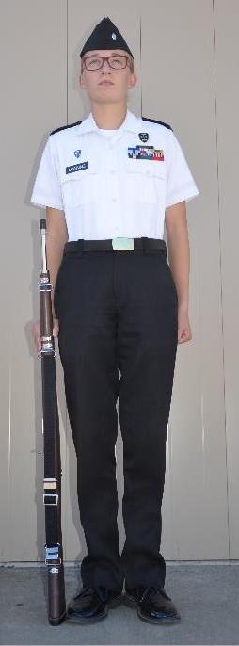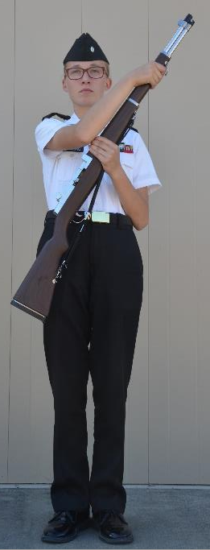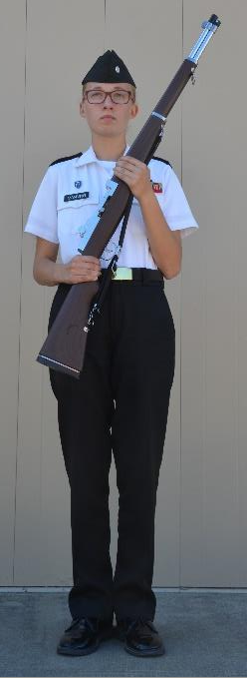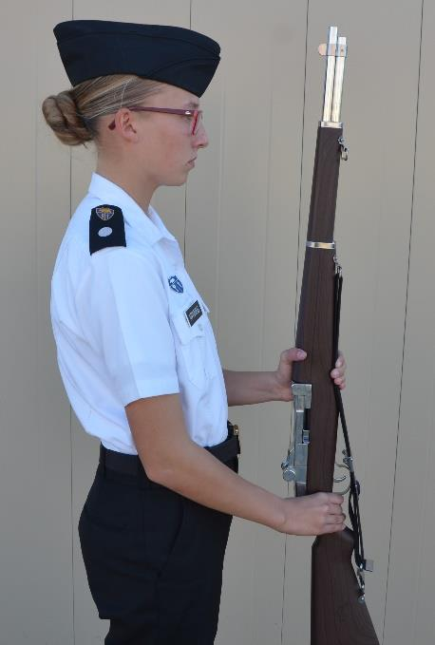

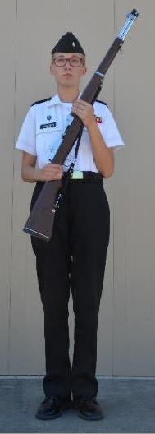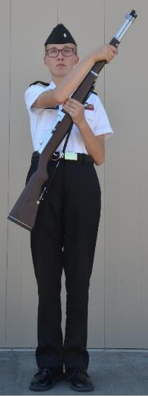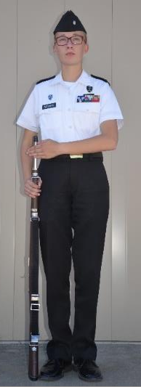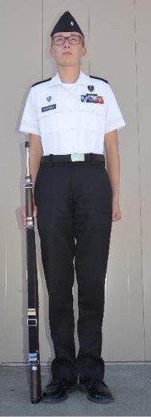

How did you do? Did you remember all the details? It’s good to highlight what you need to teach, so that you don’t forget to cover any of the important details. Drill Instructors practice until they essentially have the manual memorized. You don’t need to do that – you can teach with notes so that you make sure you cover everything. Don’t forget to rehearse your ‘class’!

